Venn End User Welcome Session
Training Guide

Training Purpose
- Build awareness
- Familiarize end users with Venn
- Set expectations
- Give end users an opportunity to ask questions

Training Structure
Outcome | Sections | Objectives | Key Takeaways
You will be prepared to set up and begin using Venn for work on your personal devices. | What is Venn? | Participants will understand why their organization is implementing Venn. | The Blue Border secures work and protects my privacy by separating business activity from my personal use of my computer.
 | User Onboarding | Participants will review resources that will guide them through their user onboarding process. | My organization has great resources available to support me in setting up and getting started with Venn.
 | Expectations for Use | Participants will understand when they will be expected to use Venn. | I need to use Venn whenever I am accessing work apps, websites, or files on my personal devices.

Preparing for Your Session
- Send out communication to those who will be expected to use Venn using resources in the Rollout Toolkit at least one week before the session.
- Customize the slide deck following the guidance below.
- Familiarize yourself with the presentation materials and practice presenting them. Make adjustments or additions in the speaker notes so that you’re ready to present with confidence.
- Remember to present your slides in slideshow or presenter view so that attendees can see everything on the slides clearly.
- Don’t forget to record your presentation for those who cannot attend live.

Customizing Your Presentation
# | Slide Image | Recommended Customizations
1 |  | - Replace [Training Date] and [Training Facilitator] in the slide subtitle with information for your session  - Optional: Add your company logo in the top right corner
10 | 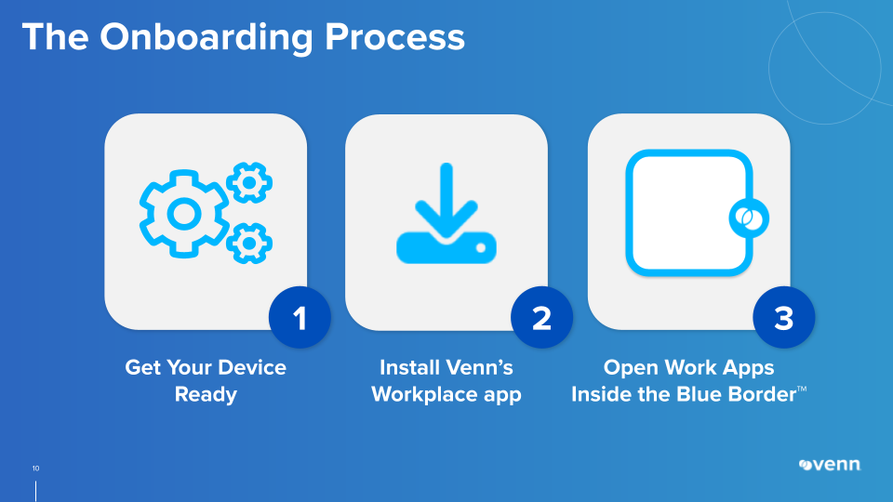 | - Replace [list essential apps for email, chat, etc.] in the speaker notes
11 | 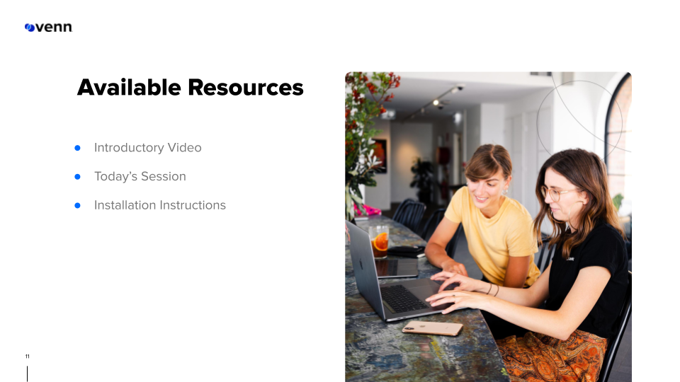 | - Add any additional resources to the slide and speaker notes  - Replace [explain where/how to find these resources] in the speaker notes
13 | 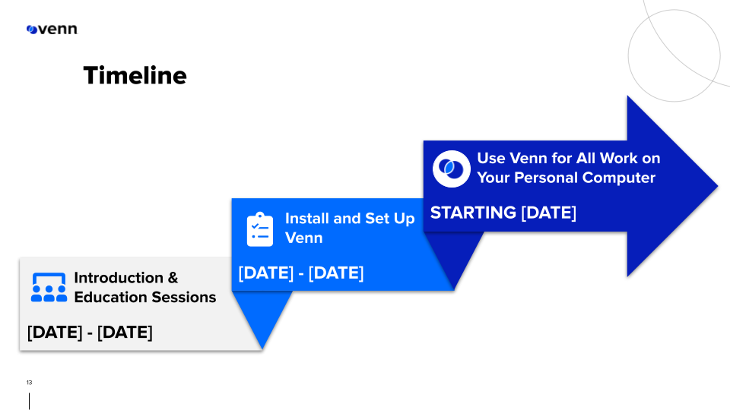 | - Update timeline on the slide  - Replace [explain timeline] in the speaker notes
14 | 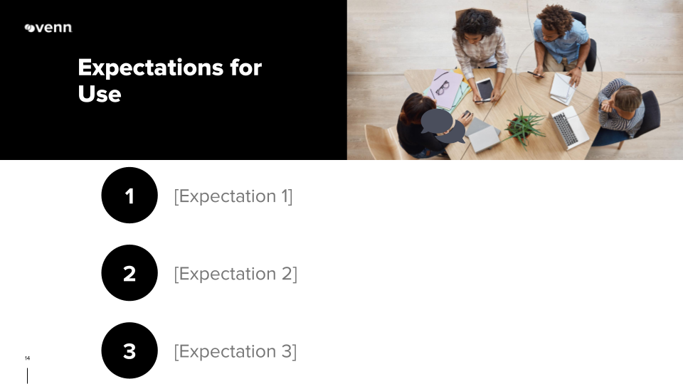 | - Update expectations on the slide  - Replace [detail expectations] in the speaker notes  - Add or remove the number of expectations as needed

